ResumÉ
Hon. Edmund Ponce de LeÓn (Ret.)  150 North MICHIGAN AVE #2800, Chicago, Illinois 60601  Office: (312) 863-8610  Current Practice:  Mediation, Arbitration and Consultations  objective: Appointment as mediator | 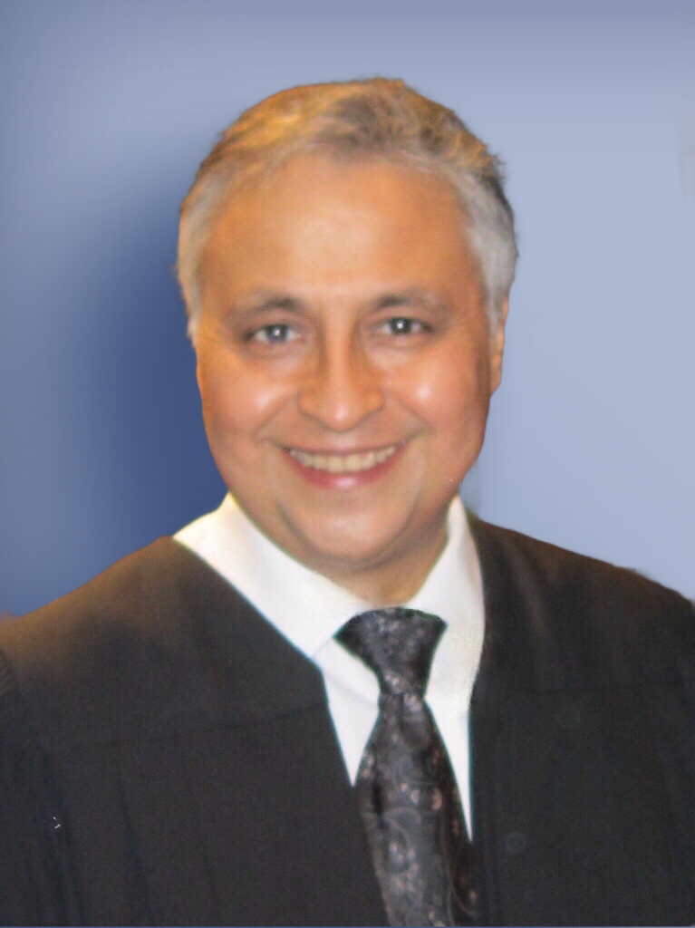
Professional Experience
Law Division – Circuit Court of Cook County, Illinois – 2015
- Presided over pre-trial motion call, Law-jury, “Tax and Miscellaneous” Section; and Commercial Law Section.

Presiding Judge – County Division, Richard J. Daley Center – 2010
- Administratiive and supervisory responsibilities over judiciary and circuit court departments
- Presided over Adoption Cases, Election, Property Tax Appeals, Mental Health, Tax Deed Sales, name changes and other County Division matters, including various pre-trial settlement conferences.
Presiding Judge – 4th Municipal District, Maywood, Il. - February 2002
- Administratiive and supervisory responsibilities over judiciary and circuit court departments
- Presiding over Civil and Criminal Cases, including Domestic Relations matter, felony, misdemeanor, traffic, tort, commercial, and other civil cases matters; including pre-trial settlement conferences.
- Member of the Executive Committee of the Office of the Chief Judge, which includes the revision of local rules of civil and criminal procedure, judiciary unethical conduct issues, including selection of associate judges.
Law Division - 2001
- Commercial Section: Assigned to preside over an iccIndividual Commercial Calendar handling complex commercial and consumer law cases, including professional negligence and business torts; including various pre-trial settlement conferences.

Domestic Relations Division - 1996
- Presided over divorce, custody and paternity matters, including pre-trial, trial and post-decree matters, including engaged in various pre-trial settlement conferences.
- 1984 to 1996 Law Offices of Edmund Ponce de Leon, Esq. Chicago, Illinois. Private practice involved mainly Domestic Relations and Probate Matters. Also from 1992 to 1996, was “of counsel” to U.S. Trustee, Rodriguez & Villalobos assisting in consumer and commercial bankruptcy litigation. Engaged in many settlement conferences.
Education And Professional Licenses
- Northwestern School of Professional Studies – Mediation Skills Certificate – 2017
- Chicago Conflict of Resolution (CCR) – Mediation Training – 1985-1986
- Juris Doctor Degree – 1984. John Marshall Law School, Chicago. Honors: Bureau of National Affairs Award – American Jurisprudence Award – Criminal Procedure.
- Admitted Illinois Bar – May, 1984; Northern District of Illinois – June 1984, and Federal Trial Bar – 1990

Lectures and Publications
- Lecture - Domestic Relations: leture faculty panel “Nuts and Bolts on Domestic Relations Practice” to bench and bar members sponsored by The Office of the Chief Judge and Domestic Relations – Fall 1999
- Illinois Supreme Court (AOIC) faculty lecture panel: “Financial Issues in Family Law” (presented to Downstate and Cook County Judges (1999 & 2000)). Bench Book Section publication.
- Lecture - “Professional Negligence in Matrimonial Law”, Young Lawyers Section and the Matrimonial law, Chicago Bar Association – 1999, 2000
- Lecture panel: Custody (2000) and Psychological Testing in Custody Evaluations - 2001 – Domestic Relations Div.
- Lecture: “Bankruptcy and Divorce”; Chicago Bar Association Domestic Relations Committee - 2000
- Published “Bankruptcy and Divorce” featured in the “Article of the Month” of the Family Law Reporter, and the seminal book on Family Law: “Gitlin on Divorce” - 2000 Edition.
- Lecture - Law Division Commercial Section: “Arbitration and Business Torts” – 2001; Bench book publication.
- Illinois Supreme Court (AOIC) faculty lecture panel: “Commercial and Consumer Law” 2002;
- Lecture - Law Division Commercial Section: “Liability in Corporate Settings - Alter Ego, Shareholder Oppression and Fiduciary Relationships” – 2001; Bench Book Section publication.
- Lecture - Law Division Commercial Section: “Revisiting the 1996 amendments to the Discovery Rules” 2002. Bench Book Section publication.
- Illinois Supreme Court appointment to Lecture Panel: “Commercial & Consumer Law” – 2002
- Illinois Supreme Court appointment to Lecture Panel: “Financial Issues In Family Law” -– 2000
- Illinois Supreme Court appointment to Lecture Panel: “Adoptions & Guardianship” – 2010
- Article as part of Adoption Book on Circuit Court Procedure, Illinois Institute Of Contuing Education- 2014
- Moot Court Judge for National Criminal Moot Court Competition – 2002, 2003 (Final). Appellate Moot Court Justice: John Marshall Law School and Trial Moot Court Judge: DePaul University College of Law.
- Lecture - The Lilac Tree Women’s Group. Lectured “Your rights and what to expect in Divorce” – 2000.
- The Women’s Bar Association: “Mechanics of running for Judgeship” – 1999.
Professional Awards
- “Distinguished” Awards upon retirement: West Suburban Bar Association - 2016 and Law Division, Circuit Court of Cook County – 2016
- “Judge of the Year” Award from the “Illinois Committee for Honest Government” – 2002
- Achievement Award: Women’s Bar Association, Puerto Rican Bar Association, and Ill. Hispanic Lawyers Assn – 2002
- “Certificates of Appreciation” from presiding Judges of Domestic Relations, Judges’ Jacobius and Evans
- Cook County Board Proclamation for judicial achievement - awarded March 2002
- The “Divine Praise” Award for achievement in furtherance of women’s rights – 2000.
- The John Marshall Law School Achievement Award – 2001
- Hispanic Student Bar Association Achievement Award – The John Marshall Law School – 2002
- “Certificate of Recognition” by Illinois State Senate (1995) for volunteer work in the “Citizenship Project”
- United States Hispanic Leadership Institute Recognition
- Boy Scouts of America Award for contribution as a Merit Badge Counselor in Law – 2002
- “President’s” Award – Latinos of Berwyn and Cicero – 2002
- “Citizen of the Year” Award – Mexican American Police Association – 2002
- NCAAP “Legal Award” - February 20, 2003
- Nominated for the 2003 “Freedom Award” The John Marshall Law School

Special Appointments and Other Achievements
- Special Mentor for troubled judges; appointed Illinois Supreme Court - 2014
- Official Mentor for new Judges appointed by the Mentoring Program Committee – AOIC.
- The Illinois Judicial Speakers Bureau 1999-2002
- Board Member of the West Suburban Bar Association.
- Board Member – U. S. Catholic Charities of Illinois – 2003
- Criminal Justice Section of the “Committee on Racial, Ethnic and Sexual Orientation Awareness in the Courts”.
- The Adult-Probation Committee of The Circuit Court of Cook County, - 1999 -– present.
- Co-Chair of the Child Representative Program, Domestic Relations Division -– 2001
- Chairman Domestic Violence Committee of Circuit Court of Cook County 4th District 2002 to present.
- Advisory Board Member to the “Traffic Safety Committee” –Circuit Court of Cook County – 2002
- Advisory Board Member to the “Adult-Probation Mentoring Program” of Circuit Court of Cook County.
- Chicago Bar Association: Criminal Law, Corporate and Consumer Law, Judiciary.
- “The ASPIRA Mentoring Program for young Hispanics”.
- “Youth Motivational Program” for students at Roberto Clemente High School.
- Member: Association for Conflict Resolution; Chicago Bar Association, Illinois Bar Association, Illinois Judges Association, Illinois Hispanic. Lawyers Association, Puerto Rican Bar Association
- Judicial Evaluations: Judicial Retention 2002, 2008 & 2014 – “Qualified” by all Bar Associations; Appellate Court Candidate, 2003 – “Qualified” by all Bar Association.

Professional References

Hon. Timothy C. Evans
Chief Judge
Circuit Court of Cook County
50 W. Washington Street
Chicago, Illinois
312-603-6000

Hon. James Flannery
Presiding Judge, Law Division
Circuit Court of Cook County
50 W. Washington Street
Chicago, Illinois 60602
312-603- 6343

Hon. Moshe Jacobius
Presiding Judge, Chancery Division
Circuit Court of Cook County
50 W. Washington Street
Chicago, Illinois 60602
312-603- 4181

Hon. Grace Dickler
Presididing Judge, Domestic Relations
Circuit Court of Cook County
50;W. Washington Street
Chicago, Illinois 60602
(312) 603-3025

